Sullington Warren Excavation Project Design

Figure 1: Sullington Common (c) Google Maps

Contents
Introduction 3
Site Location and Geology 3
Historical and Archaeological Background 3
Research Aims 3
Methodology 3
Site Records 3
Metal Detecting 4
Timescale and Duration of Work 4
Land Ownership and Access 4
Written Report 4
Deposition of Archive and Finds 4
Specific Health and Safety Issues 4
Finds Tent and Equipment Storage 4
Risk Assessment 5
Finance & Expenses 5
Insurance 5
Availability of Water and Toilets 5
Site Supervision 5
References 5

Introduction
The purpose of the Project Design is to outline a proposed excavation to be undertaken at National Trust’s (NT) Sullington Warren over a week in the period April to June 2024.
The aim of the excavation is to gain a better understanding of the linear features appearing on the area of the warren known as ‘The Lawn or Green’ (NT monument 121846) – hereafter referred to as The Lawn. These features have appeared as crop marks (Brown 2021) and as anomalies on a GPR survey (Lovell, 2023).
Initially two trenches will be excavated to determine the nature of the linear features shown in figure 2 below. The exact location of the trenches has yet to be finalised.
The excavation will be undertaken by a team consisting of Worthing Archaeological Society Field Unit (WASFU members) and National Trust volunteers.

Site Location and Geology
Figure 2 below shows the outline of the Lawn together with the scheduled monuments. The excavations will focus on the lawn, showing the linear crop marks, which may indicate the past presence of buildings.
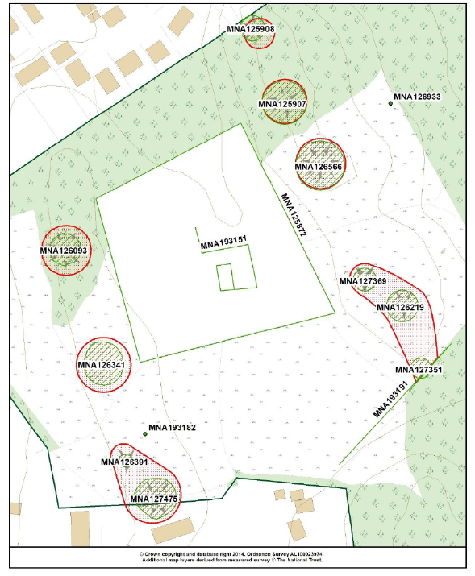
Figure 2: Sullington Warren, Scheduled Monuments (from Brown 2021)
The Lawn is centred on TQ09571449. The site is located on the Lower Greensand ridges and consists of poor sandy acidic soils. The Lawn is primarily laid to grass (which is maintained by the National Trust), the surrounding area is covered in typical heathland vegetation i.e., bracken and heather.

Historical and Archaeological Background

Historical Background
Primarily based on Joy Ede’s 1997 Archaeological and Land Use History Report (SNA69730).
Mesolithic activity is the earliest period represented on this property. Several pieces of flintwork dating from the Mesolithic have been found on paths.
There are at least ten early Bronze Age round barrows on two Lower Greensand ridges, running north south. There may also be other barrows on lower areas of the property although their identification is by no means positive. In this period and earlier in the Neolithic this area was probably cultivated. After about the Middle Bronze Age soils would have been so acidic and poor that cultivation was no longer feasible and the area was used to graze animals.
This grazing continued for many centuries preventing the regrowth of the woodland. Fire may also have helped keep this area open and dominated by ericaceous shrubs rather than grass.
In the 19th century a windmill was built on the hill in the southern part of the property. This was used throughout the century and fell into disuse in about 1907. In 1911 it was burnt down accidentally by a fire which swept across the whole property.
In the mid-19th century two enclosures were constructed by surrounding areas of land with a bank and ditch. One enclosure in the middle of the property on sloping ground was used until the First World War to cultivate crops such as oats. The other enclosure, if it was used for arable cultivation, did not last long. By 1875 it was shown on the Ordnance Survey map as rough pasture with scattered trees.
At some period in the past there was small scale quarrying, for sand and for gravel. This activity has left many small hollows, particularly in the southern half of the property. There are other hollows in the northeast of the property which are of unknown function and date.

Archaeological Background
The Bronze Age Barrow cemetery was partly excavated in 1809 when cinerary urns and burnt human bones were found. We don’t know which ones and I don’t have any of the reports. Grinsell 1940 and Ede 1997 reference Cartright 1830?
Work of Sandgate Conservation society on various steps and paths up monuments? 1976 MNA126566 | National Trust Heritage Records
Condition Assessments Dommett 2017 and Brown 2021
Recent survey and geophysics by Portsmouth Uni

Research Aims
The research aims of this proposed excavations are:
To determine the nature of the features appearing as crop marks and anomalies in the recent GPR survey. Do they relate to a building or structure and are any associated finds to assist in the dating of the building? Determining these features will help enhance the knowledge of changing land use of Sullington Warren. The information will help inform future management of the site.
Provide an opportunity to upskill volunteers in archaeological techniques and engage with the local community. The site is well used by local community for recreation and exercise, but it is not known how well understood the site is. Engaging visitors in the site’s history will hopefully widen understanding and help build a desire to value and protect the site.

Methodology
The intention is open two trenches by machine. The trenches will be a minimum of 0.75m wide with the length depending on what features are uncovered and if necessary, will be extended sideways.
The backfilling will be done by machine, with NT to reinstate the turf or reseed.
Currently there are no plans to undertake any further geophysical surveys.

Site Records
Standard WAS processes will be followed for the excavation. This will include:
- Context Recording
Each context will be assigned a unique ID and WAS pro forma context sheets used to record them.
- Drawings
Section drawings will be recorded at 1:10 and if plan drawings prove feasible these will be recorded at 1:20.
- Surveying
The site will be surveyed using the total station to record position and height information. A set of temporary bench marks will be established prior to the excavation and will form the basis for the surveying of the trench and any small finds.
- Artefacts
Where artefacts are considered to be in context they will be recorded as set out in First Aid for Finds (Watkinson and Neal, 1998).
The site code will be SW2024 with the first trench assigned the id of A. Context numbering will start with 001. The second trench will be assigned the id of B, and will use the same Context Register as trench A.

Metal Detecting

Timescale and Duration of Work
The current plan is to undertake the excavations at the start of May for nine days, with the last two days earmarked for recording and ‘striking camp’.
The excavation will be undertaken by the WAS Field Unit with up to 10 volunteers with links to the National Trust:

Land Ownership and Access
WAS Field Unit are undertaking this work because of an invitation by the landowners (National Trust).
Limited parking is available on-site, with a public car park located 10 minutes’ walk from site.
Need to agree how many cars can park on-site, as we do not want to set a precedent. Also, need to agree if parking is available on track leading up to the common.

Written Report
WASFU will undertake the processing of finds with support from subject experts where applicable.
An excavation report will be produced by WASFU Director in conjunction with James Brown (NT Archaeologist). This report will be sent to the NT and appear on the WAS website.

Deposition of Archive and Finds
All finds and site records will be stored at the WASFU facility at the NT Regional Office at Slindon, West Sussex.
As any finds belong to the National Trust, these will be retained until instructed otherwise by the National Trust (as per current WAS Finds Policy).

Specific Health and Safety Issues
Further to a site visit undertaken in November 2023, there does not appear to be any specific H&S issues relating to this site. However, the Lawn is used by a number of dog walkers, therefore it will be necessary to ensure that the site (especially the trenches) are securely fenced off.

Finds Tent and Equipment Storage
Due to the level of public access to the site, it is recommended that the Finds Tent is not used and instead the gazebos are used to provide shelter.
There are no secure storage facilities available for equipment and finds. Therefore, these will need to be removed from the site at the end of each day.

Risk Assessment
A risk assessment form will be completed and added as an appendix to the final version of the Project Design.

Finance & Expenses
Post excavation work will be undertaken by Worthing Archaeological Society volunteers and the committee will decide whether to fund more detailed specialist interpretation of samples and artefacts.
The National Trust will provide the machinery to open and backfill the trench.

Insurance
WAS has archaeological site insurance and public liability insurance.
All participants must be fully paid-up members of WAS to be covered by WAS Insurance (but a day membership fee can be paid.) Anyone taking part who is not covered by WAS insurance must have suitable insurance from a partner organisation.
Participants must also complete a Health & Safety/Indemnity Form, which is valid for a year and which details any health issues and an emergency contact. Since this information is confidential it will be held securely by the project director. The forms are on the WAS website: https://www.worthingarchaeological.org/.
A site attendance record will be used for participants to sign in and out each day. The WAS policy on personal data is available at: obtain most up to date link from WAS website.
The depth of excavation is limited to two metres (although the site director and supervisors will review safety of trench walls and standing structures throughout the dig and halt further excavation before a depth of two metres if unsafe to continue). However, it is unlikely that the trench will need to be this deep.

Availability of Water and Toilets
Due to the site’s location, there is no access to water, therefore all water will need to brought to site for finds processing or drinking.
The National Trust will provide on-site toilet facilities.

Site Supervision
The excavation will be directed by the WAS Field Unit Director, assisted by site supervisors.

References
Brown, J. 2021 Sullington Warren, West Sussex: Scheduled Monument Assessment.
Ede, J. 1997 Sullington Warren, West Sussex, An Archaeological and Land Use History Report.
Ede, J. 1997 Sullington Warren, West Sussex, Archaeological Sites and Monuments Inventory Listing.

Further Reading
Drewett, P. 1976 ‘The excavation of four round barrows at West Hearth, Harting, 1973-75’, SAC 114, 126-150.
Gould, D. 2017 ‘The Distribution of Rabbit Warrens in Medieval England: An East-West Divide?’, Landscape History 38, 25-41.

